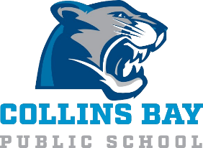
School Advisory Council Meeting Minutes
Mar 24, 2026

Attendance:
Alyssa Baird
Jennifer Cole
Val Boyce
Jenna Lee
Holly Moore McQuaid
Lauren Desarmia

- Principal’s report – J. Cole
    - Staffing Process
        - School profile developed
        - 25/26 Class breakdown
          - JK – grade 2 – 16
          - Grade 3 – 4 – 17
          - Grade 5 – 8 – 26
        - 26/27 projected classes
          - JK – grade 2 – 15
          - Grade 3 – 5 – 19
          - Grade 6 – 8 – 19
    - Upcoming events
        - Basketball tournament beginning of May
        - Play – May 14 & 15
        - RKY Camp – June 17
        - IEPs sent home for term 2
        - Talent Show Fri Mar 27th – 240 pm
        - Upcoming Milkshake days (on school day)

- Treasurer’s report – A. Baird
    - Bingo funds - $22496.63 as of 6 Mar
    - Parent Engagement funds - $2334.62 – can be used for refreshments, baby sitting and parent info night (board game night?)
    - Kassy looking into ideas to spend funds
New Items:
- Bingo fundraising
    - New schedule has been added – volunteers please register as schedule allows

- Year End Celebration Update
    - Discuss progress: Lucky Inflatables, The Great Canadian Country Cabin Chip truck
    - Games & foam pit secured, working on details for food
    - Looking into Kona Ice truck
    - Val to purchase drinks
    - Need to confirm time (4:30 to 6:30?)

- Spring Play
    - Script purchased
    - Will be some purchases for costumes and props upcoming
    - Purchases NTE $1000 total

- Upcoming Purchases
    - $500 for headphone (roughly 50 pairs)

Date of next meeting: Thursday May 7th 2026 at 5:30 in the library.

