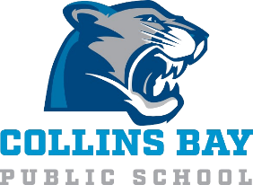
School Advisory Council Meeting Minutes
Jan 20, 2026

In Attendance:
Jennifer Cole
Val Boyce
Alyssa Baird (chair)
Charlotte Burns (virtual)
Jenna Lee
Holliday Moore-McQuaid
Lauren Desarmia

- Principal’s report – J. Cole
  - Introduction
  - Upcoming Events – Jan 29th Milkshake Day, Spirit Day (favourite storybook character), Jan 30th PA Day, Feb 16th Family Day (no school)
  - EQAO Results Delayed – Limestone at or above provincial standard
  - Biweekly Communication – Friday afternoons sent via email and posted on school website
  - Progress Reports
    - Full term will be sent home Feb 13th
  - Yard Improvement
    - Aaron reached out to board to contact consulting co (Evergreen) for quote/options – Jennifer to follow up

- Treasurer’s report –
    - $20,504.45 in bingo funds as of Jan 6 2026
    - $2334.62 in parent engagement funds

New Items:
- Spending from Previous meeting
    - Items confirmed purchased: hockey nets, foam mats, storage bins, art supplies, volleyball posts, nets and mats
Spending still to be confirmed:
    - Jerseys
- Bingo
    - Application submitted, waiting on new schedule for April 2026 to Mar 2027
    - Continue to spread info to parents

- June 10th – Fun Fair / Year End Celebration – use some parent engagement funds for event

- Spring Musical – date TBC (early to mid May)

Date and time of next meeting: Tuesday, Mar 24 at 5:30pm

